***Operating System***

***By Tarun Gothwal***

***Batch A***

1. **Create files file1 and file2 in directory dir1 and file3 in dir2.**

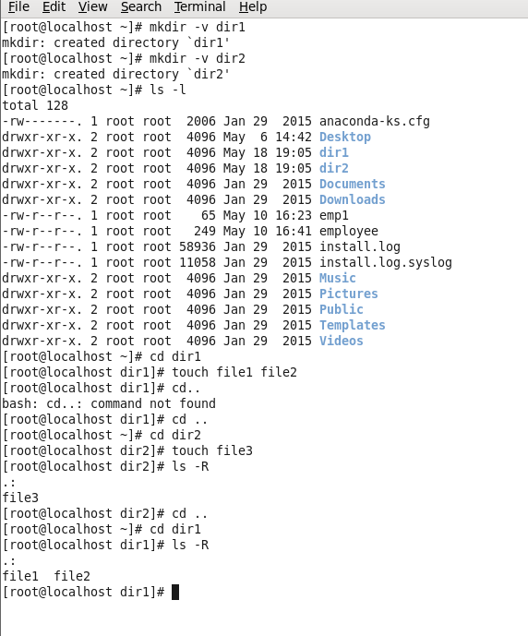

1. **Copy the contents of file1 and file 2 into file3 residing in dir2.**

**Content of file 1 and file 2 in dir1:**

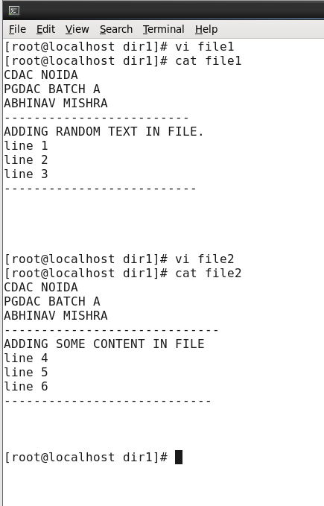

**Content of file 3 in dir2:**

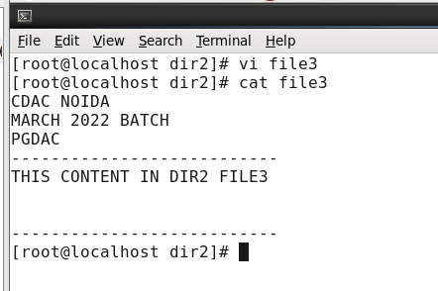

**Appending file1 and file 2 in file3 : -**

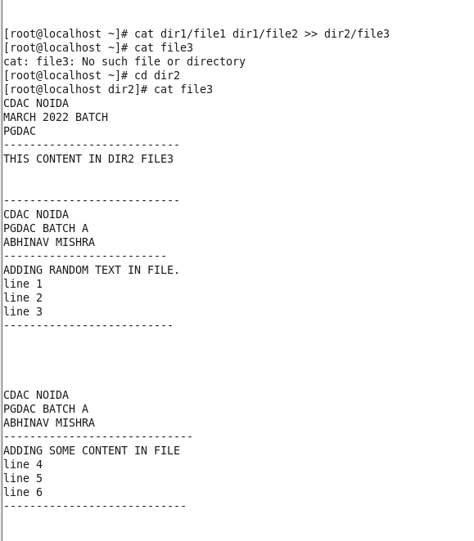

1. **Move the file file1 and file2 to the directory where file3 resides.**

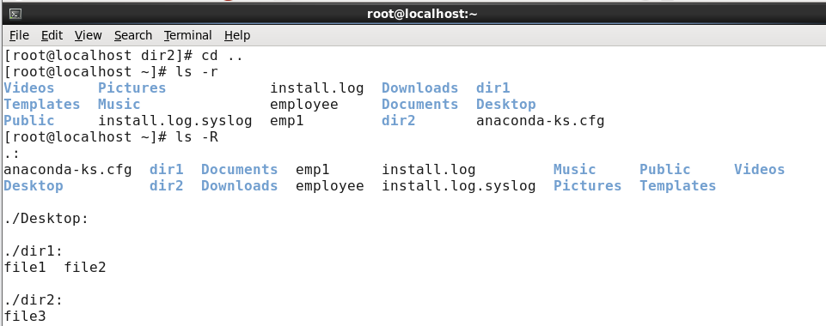

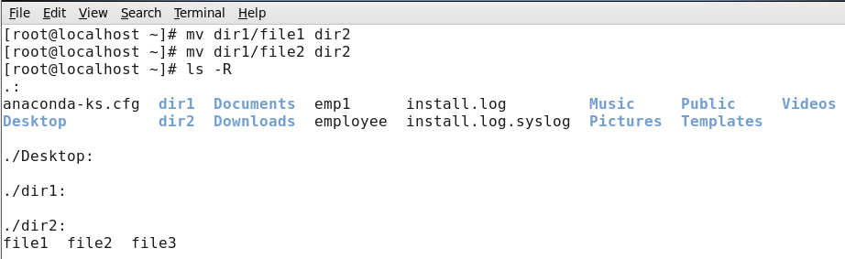

1. **Compare the contents of file 1 and file2 ignoring the 1st byte**

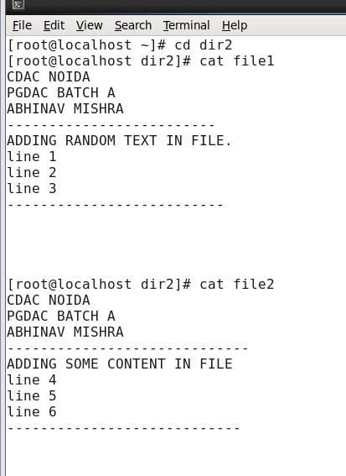

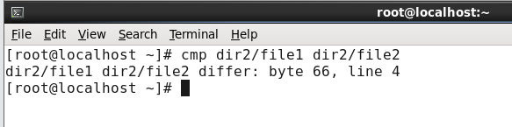

1. **Compress the contents of file3.**

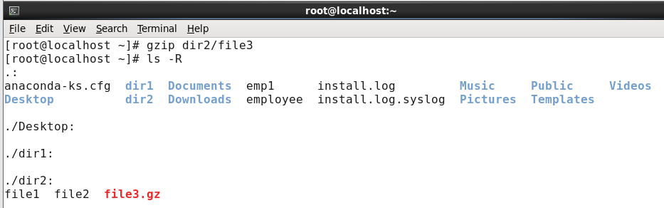

1. **Display the contents of any file 15 lines at a time starting from the 10th line.**

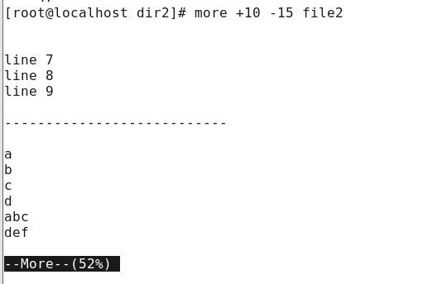

1. **Squeeze multiple blank lines to single blank line present in the file.**

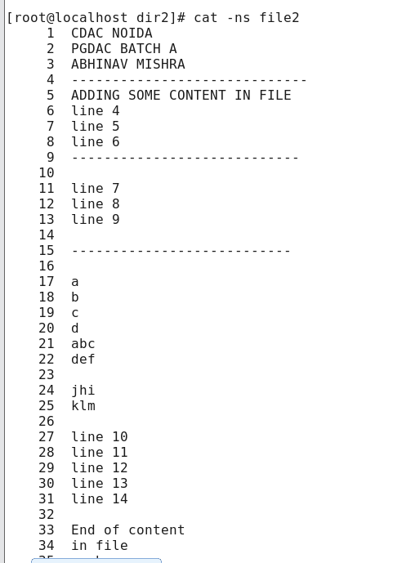

1. **Usage.**

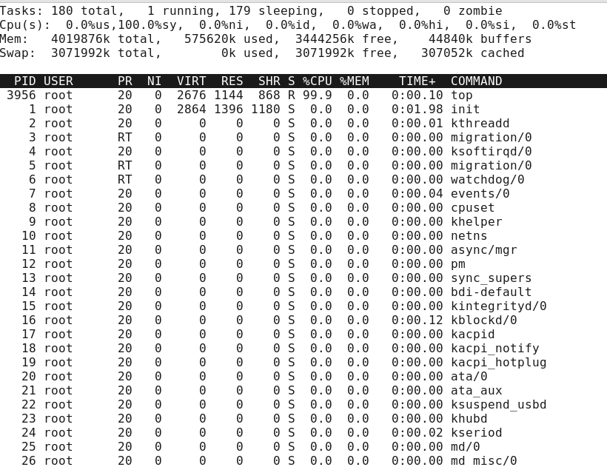

1. **How will you list the current directory in columnar format?**
2. **How will you list all the files starting with a,b or m in a directory?**

**Q9 and Q10 in below Screenshot**:

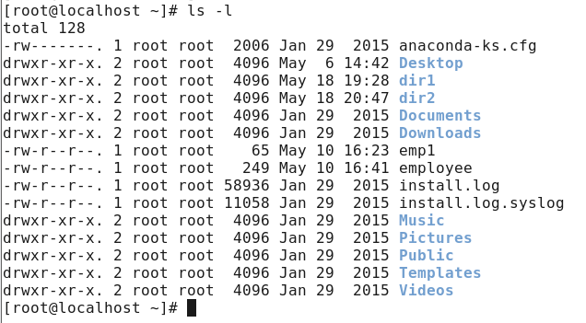

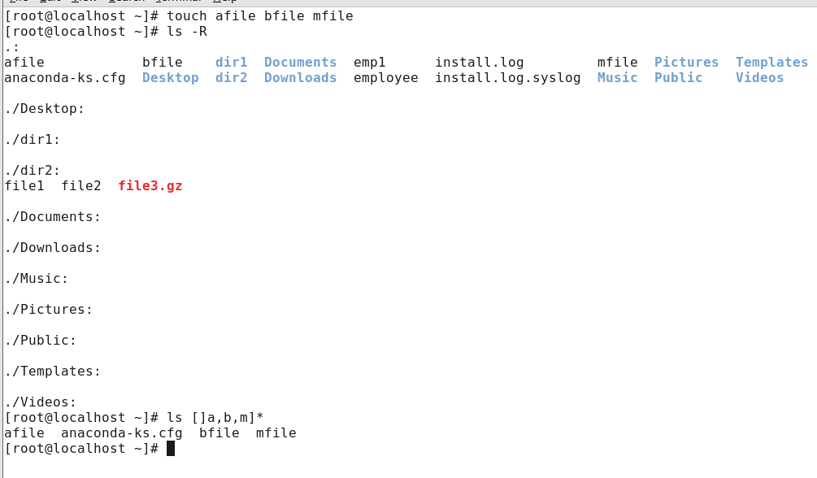

1. **How will you list all the files except files starting with a  to m in a directory?**

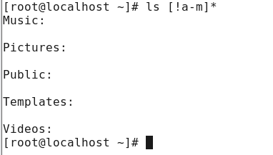

1. **Give write and execute permission to the user and group both in relative and absolute manner**

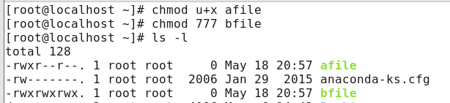

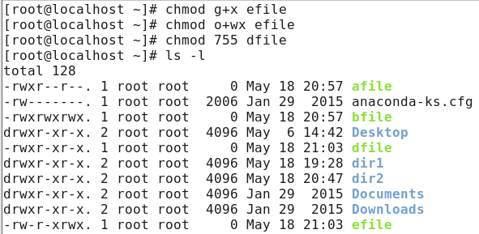

1. **Find the length of a particular string (For example, the length of the string hello is 5 )**

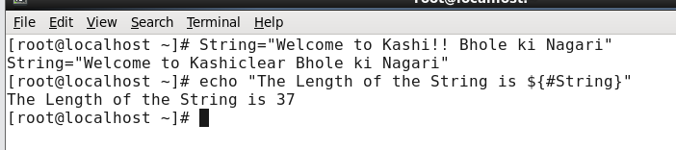

1. **List all the users who have logged in ascending order.**

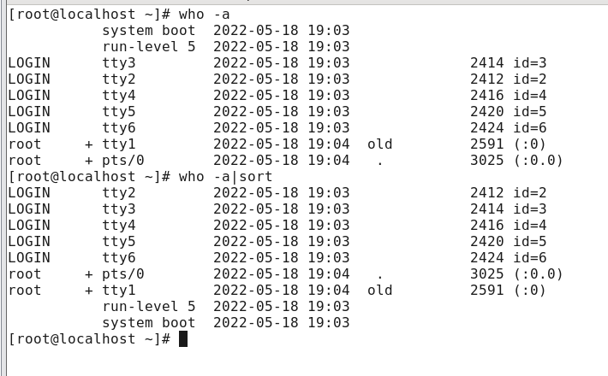

1. **How do you find out about all running processes?**

